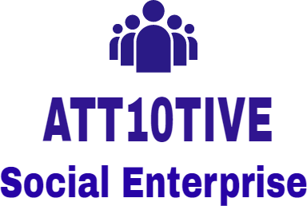
Youth Ambassador Application Form
Name
Email
Mobile number
Address & Post Code
How did you hear about Att10tive?
If you are in education where and what are you studying
If you are currently working what do you do
Background or ethnicity
Date of Birth & age

Why do you want to be a Youth Ambassador?
Tell us about any skills or knowledge that you think you can bring to our social enterprise
Please state something you have achieved or done that has made a difference to anyone or has helped any individual or organisation?
Are you interested in any of the following' If so please elaborate;
Using digital tools and apps
Photography, video & filmmaking, newspapers and magazines
Podcasts / Radio Hosting
Public speaking / debating
Social justice / law / campaigning
Theatre, acting / dance
Creative arts (painting or drawing)
Tell us how you would use social media to raise awareness or to share stories
How have you worked in a team or with a group?
What life skills would you like to develop (for example self confidence, adaptability, presentation skills)
Tell us about any committees groups or organisations you have been part of and what have you achieved
Can you commit to virtual meetings on a Tuesday evening and a further two hours per week?
Please email this form to att10tive@gmail.com

